Integrating Cayenne on TTN

RM1xx Series

Application Note v1.0

# Intro duction

Cayenne is IoT data processing system that can display transmitted data in visualized form with drag-and-drop configuration. A LoRaWAN server (e.g. The Things Network - TTN) can be set up so that it receives data from end-device and forwards that data to an external application server in the format it can understand. We captured the data such as temperature on DVK-RM191 and sent it over to Cayenne in order to show data in icon and graph.

# Requirement

* DVK-RM816 or DVK-RM191 with the latest firmware (v17.4.1.0 was used in this test with RM191)
* [UwTerminalX](https://github.com/LairdCP/UwTerminalX) (v1.03 or later recommended)
* smartBASIC application (cayenne.mydevice.sb)
* LoRaWAN gateway (e.g. [Laird Sentrius RG1xx](https://www.lairdtech.com/products/rg1xx-lora-gateway))

# Overview

This application note demonstrates that RM1xx captures data on its DVK and send it over to LoRa network. Gateway is set up as packet forwarder pointing to TTN as destination, and TTN redirect data from end-device to Cayenne MyDevice so that it can be displayed in widgets on a browser.

# Test Setup

First, DVK needs to be set so that RM1xx can access to temperature sensor and Button1, Button2 and LED5. (Figure1 and Figure2)

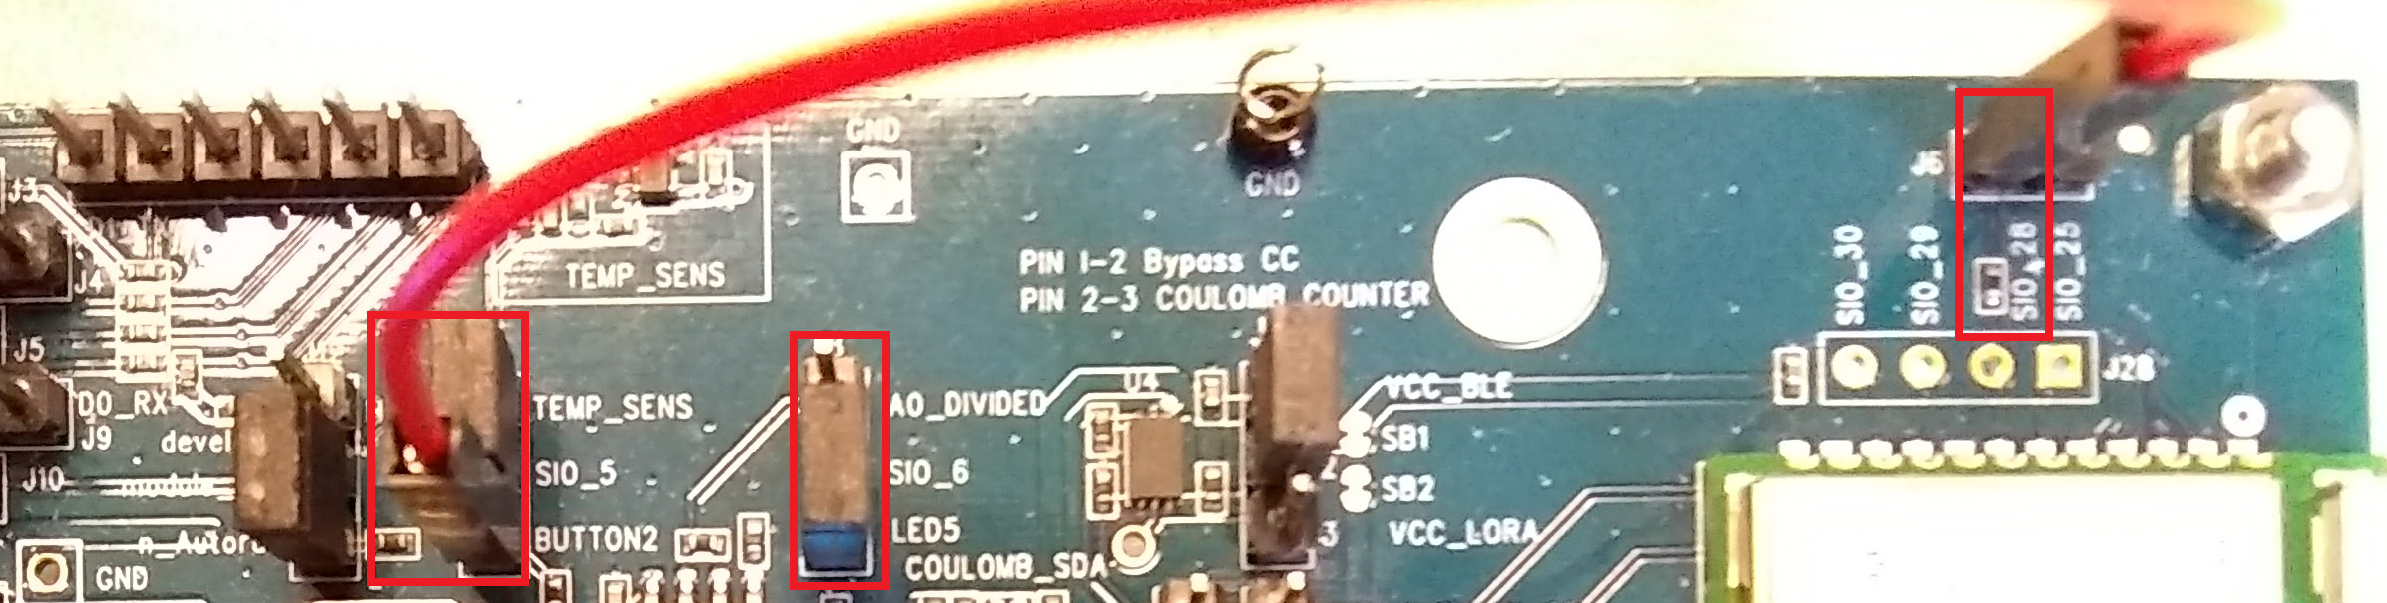

Figure 1 Hardware pin setup (J7pin1-2, J7 pin3 - SIO_28, J8 pin 1-2)

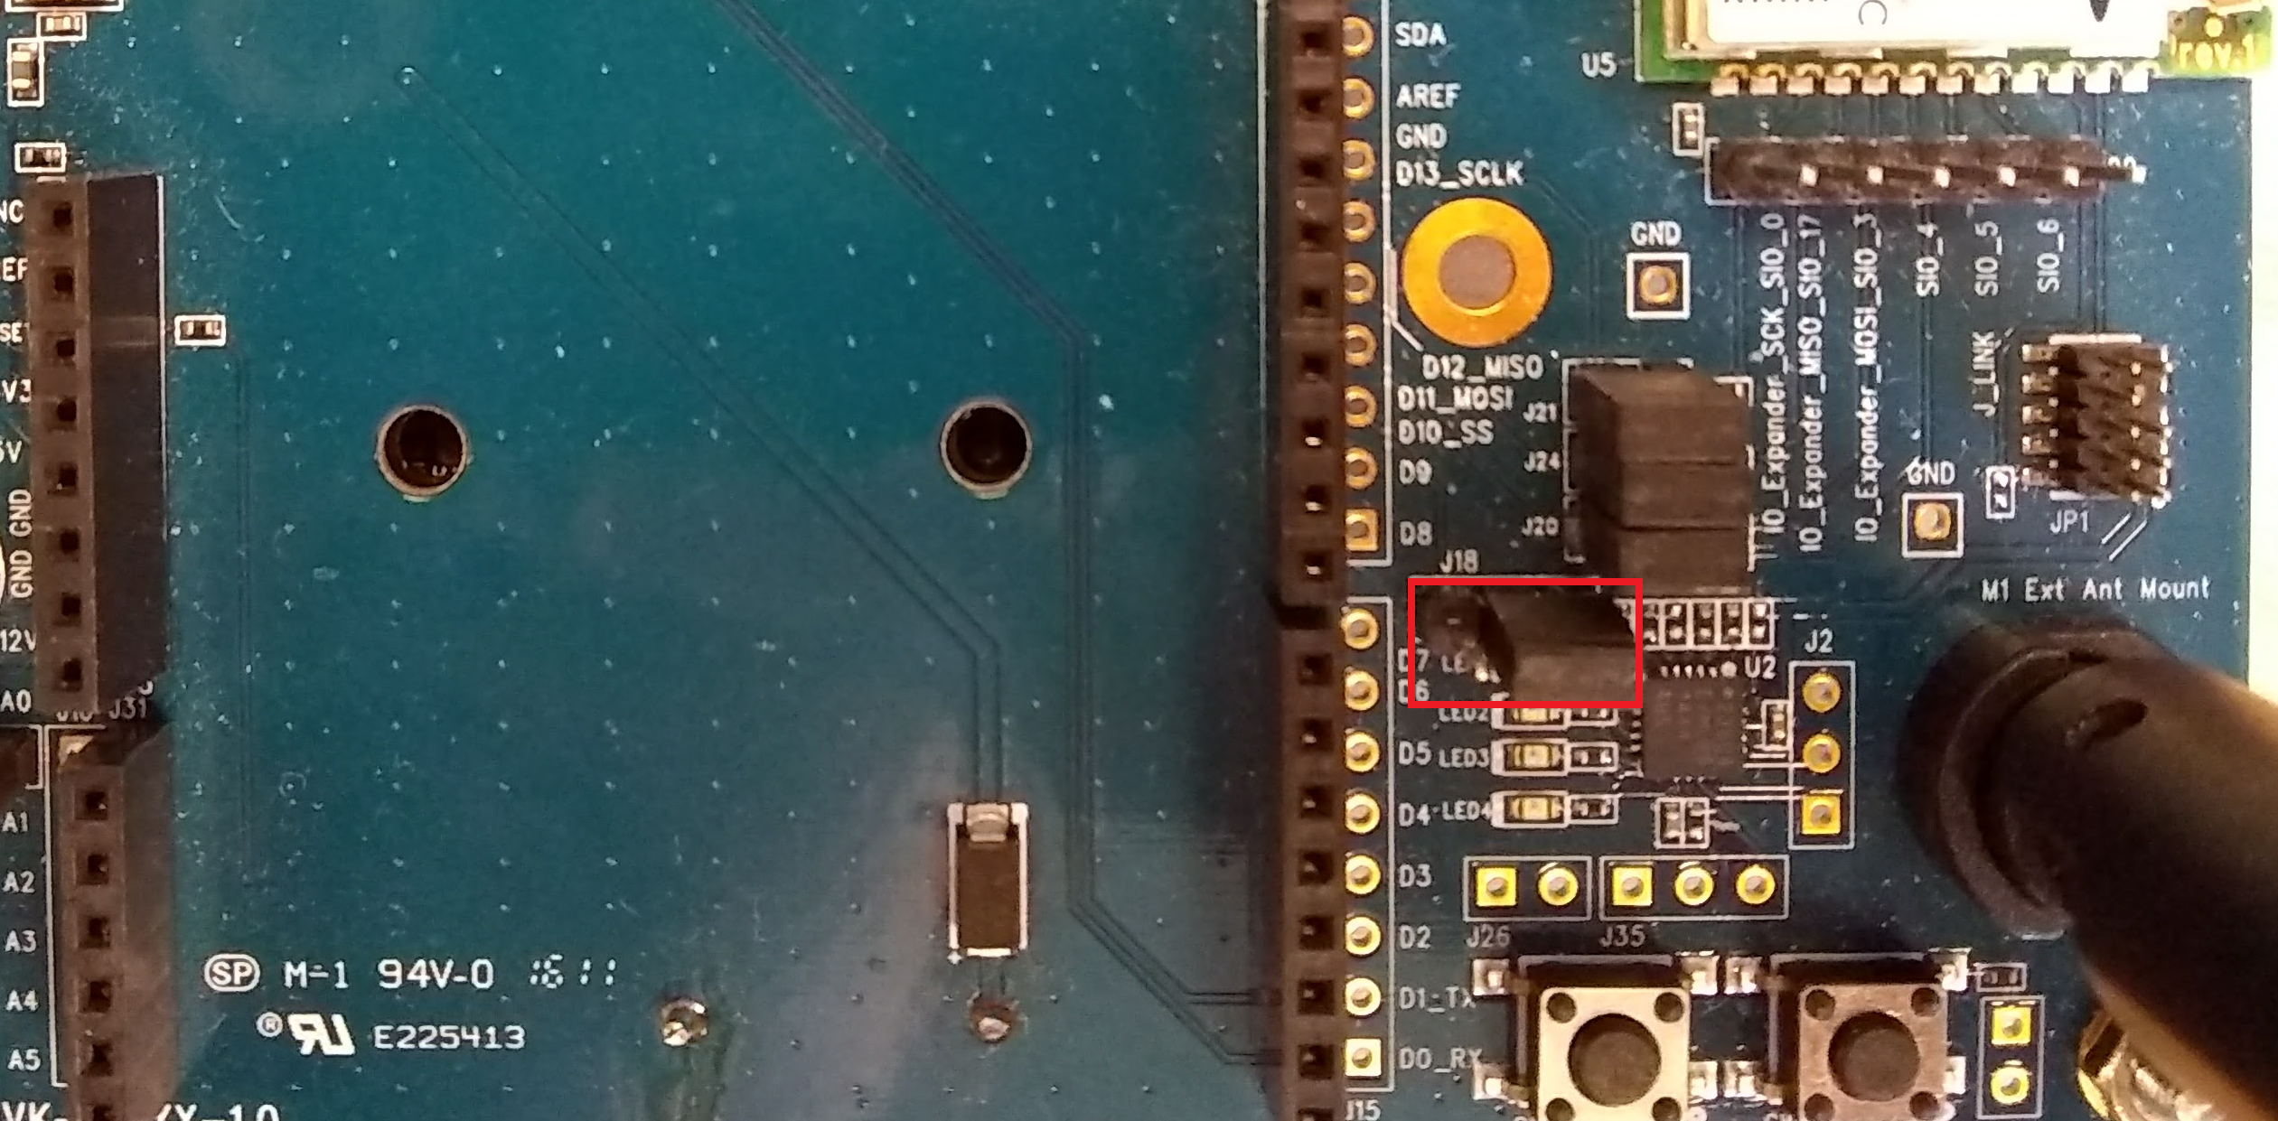

Figure 2 Hardware pin setup (J18 pin 2-3)

Now, TTN and Cayenne need to be set up.

1. Register for an account on cayenne <https://cayenne.mydevices.com/cayenne/dashboard/start> and verify your account
2. Sign up for a TTN account and login on <https://console.thethingsnetwork.org/>
3. Set up your gateway, application, end-devices on TTN

* <https://www.thethingsnetwork.org/docs/gateways/registration.html>
* <https://www.thethingsnetwork.org/docs/applications/add.html>
* <https://www.thethingsnetwork.org/docs/devices/registration.html>

1. Add a new device on Cayenne. LoRa > The Things Network > Cayenne LPP, paste the dev EUI here and add it
2. On TTN, go back to the application > integrations tab, and then click add integration and select cayenne, the process ID you get from the Cayenne page URL after the /lora/ part of the URL (for example, the highlighted in <https://cayenne.mydevices.com/cayenne/dashboard/lora/3e795080-xxxx-xxxx-xxxx-51a105d3afc2>)
3. Go to the payload formats tab and change it to ‘Cayenne LPP’ from custom.

Then, RM1xx needs to be set up.

1. Open up UwTerminal and configure AppEUI, DevEUI and AppKey that match with ones on TTN by using following command respectively.

* at+cfgex 1010 "<AppEUI>"
* at+cfgex 1011 "<DevEUI>"
* at+cfgex 1012 "<AppKey>"

1. (RM191 only) Set up the sub-band to be used. For example, following command is used to set sub-band2

* at+cfgex 1009 "0002000000000000ff00"

1. Reset via “atz”
2. Right-click on UwTerminal and clikc “XCompile + Load + Run” and choose the smartBASIC application (cayenne.mydevice.sb)
3. If successfully downloaded, the application starts immediately. RM1xx joins a LoRaWAN network and then transmit data shown on Cayenne periodically.

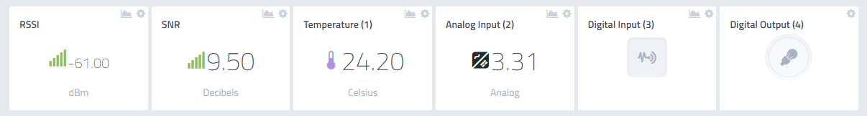

Figure 3 Displayed data on Cayenne

In figure 3, “Analog Input (2)” is the power supply/battery in voltage. “Digital input (3)” is Button1 on the DVK and “Digital Output (4)” is the LED5 status on the board. These names can be changed on setting located at the right upper corner of each widget so that they can look like figure 4, for example.

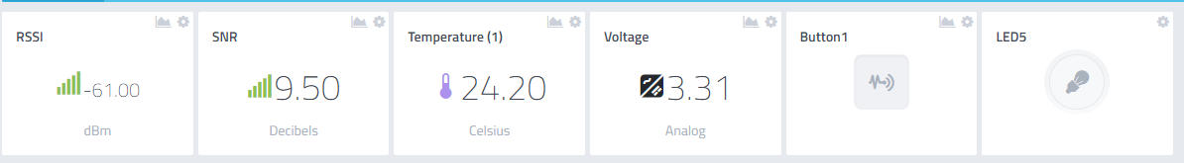

Figure 4 Renamed widgets on Cayenne

If Button2 on DVK is clicked, it will toggle LED5 status and include it in the transmitted data to Cayenne.

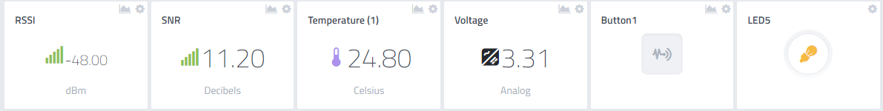

Figure 5 LED5 turned on

If Button1 is pressed while RM1xx is transmitting data, Button1 status will be updated on Cayenne.

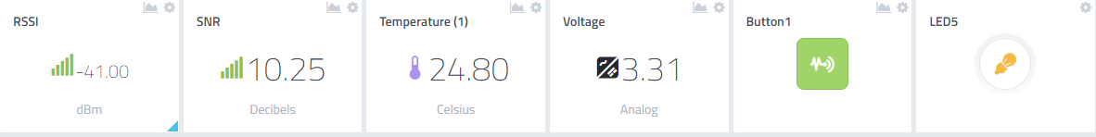

Figure 6 Button1 pressed

You can set notification on “trigger” which is located on right corner of each widget and get an email or text message when certain condition is met. The below is a setup for notification when temperature is above 20 C.

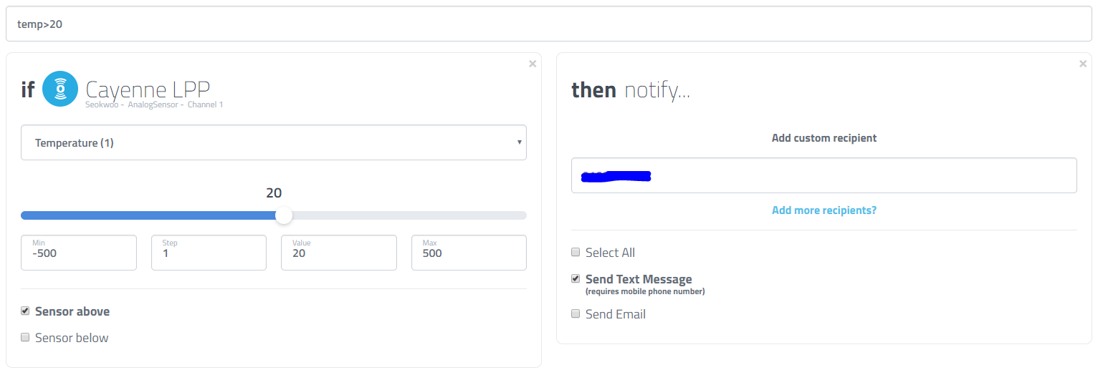

Figure 7 Notification setup for temperature above 20 C



Figure 8 Arrived text message on mobile phone

# Resources

Cayenne Payload Structure - <https://mydevices.com/cayenne/docs/lora/#lora-cayenne-low-power-payload>

RM1xx Setup Guides – <http://www.lairdtech.com/products/rm1xx-lora-modules#documentation-tab>

RM1xx Sample Applications – <https://github.com/LairdCP/RM1xx-Applications>

# Revision History

|  |  |  |  |
| --- | --- | --- | --- |
| Version | Date | Notes | Approver |
| 1.0 | 29 Sept 2017 | Initial Release | Seokwoo Yoon |
|  |  |  |  |